**Successes**

We can demonstrate that for simple problems such as the MNIST handwritten digit recognition (see Appendix X), we can easily outperform the baseline kNN approach using a CNN. Even though we have failed to demonstrate better performance classifying our α-whales dataset using a CNN vs the kNN we can still produce statistically significant results of about 14% (look into proving statistical significance) classification accuracy on the validation set. This is much greater than a random guess of 1/38 = 0.0263, but not as high as the 20% value from kNN.

We have been able to show that many of the filters that we trained with our convolutional layers are in fact detecting the callosity patterns of the whales with different levels of activations (close to zero or closer to one) and with different types of filters. Some of the filters act as high pass filters – which act edge detectors and some as low pass smoothing filters.

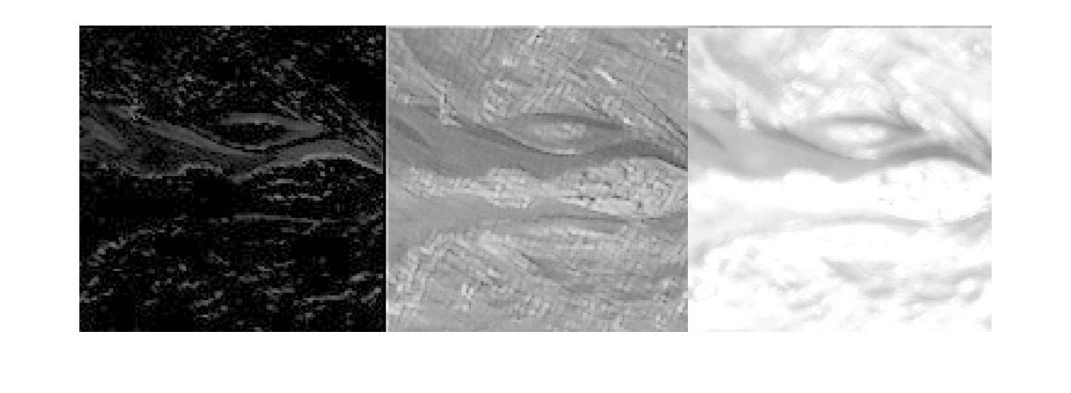

Figure X: Output of a sample neuron layer.

1. High pass filter. Low activation levels overall (close to zero mean) does not show the callosity pattern at all and the activated patterns are mostly noise from the waves. Perhaps the outline of the whale could be useful to deeper layers.
2. Low pass filter. Average activation levels (as seen by the gray levels), very clear callosity pattern and the features from the waves have been smoothed.
3. Low pass filter. Very high overall activation. Similar features to (b) with a good callosity pattern but with slightly more noise – this filter is probably still useful.

Another success of the project is to note that we have qualitatively verified that stacks of small convolutions such as the ones proposed by [ref: Oxford VGG] are easier to work with and converge much faster than networks with large convolution kernels. We suspect that many successful projects in the short term will adopt a similar approach, in fact the winner of the Kaggle competition – Deep Sense used a simplified VGG net.